Experiment Title 1.3

**Student Name: Simran Priya UID: 21BCS10370**

**Branch: Computer Science Engineering Section/Group: 907 B**

**Semester: 3RD Date of Performance: 02/09/2022 Subject Name: Database Management System Subject Code: 21CSH-214**

1. **AIM**:

Introduction and implementation of programs using Block Structure and variables.

1. **S/W Requirement:**

Oracle Database 11g Express Edition

1. **Practical:**

# Introduction to PL/SQL

* + PL/SQL stands for Procedural Language extension of SQL.
  + PL/SQL is a combination of SQL along with the procedural features of programming languages.
  + It was developed by Oracle Corporation in the early 90’s to enhance the capabilities of SQL.

# The PL/SQL Engine:

Oracle uses a PL/SQL engine to processes the PL/SQL statements. A PL/SQL code can be stored in the client system (client-side) or in the database (server-side).

# A Simple PL/SQL Block:

DECLARE

Variable declaration BEGIN

Program Execution EXCEPTION

Exception handling END;

# Declaration Section:

The Declaration section of a PL/SQL Block starts with the reserved keyword DECLARE. This section is optional and is used to declare any placeholders like variables, constants, records and cursors, which are used to manipulate data in the execution section.

# Execution Section:

The Execution section of a PL/SQL Block starts with the reserved keyword BEGIN and ends with END. This is a mandatory section and is the section where the program logic is written to perform any task. The programmatic constructs like loops, conditional statement and SQL statements form the part of execution section.

# Exception Section:

The Exception section of a PL/SQL Block starts with the reserved keyword EXCEPTION. This section is optional. Any errors in the program can be handled in this section, so that the PL/SQL Blocks terminates gracefully. If the PL/SQL Block contains exceptions that cannot be handled, the Block terminates abruptly with errors.

**PROGRAM:-**

1. 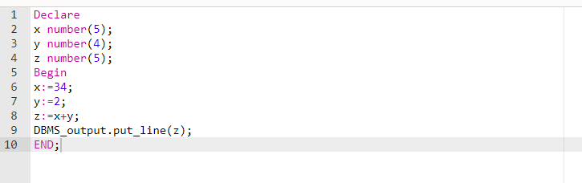Addition of two numbers:-
2. 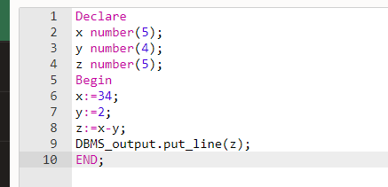Subtraction of two numbers:-
3. NAME PRINT:-

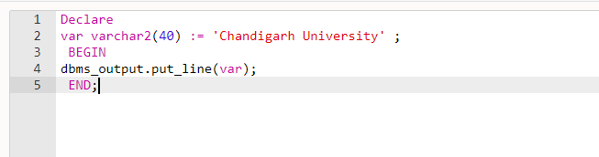

**OUTPUT:**

* 1. 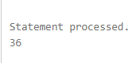addition of two numbers:-
  2. subtraction of two numbers:-

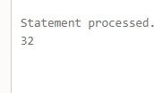

* 1. NAME PRINT:-

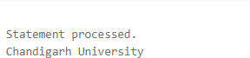

**Learning outcomes (What I have learnt):**

* + 1. **Learnt how to implement the various operations in SQL such as Like,Or,Order by etc.**
    2. **Learnt how to use Oracle Live SQL.**
    3. **Learnt how to find any detail which I require from a database. Evaluation Grid:**

|  |  |  |  |
| --- | --- | --- | --- |
| **Sr. No.** | **Parameters** | **Marks Obtained** | **Maximum Marks** |
| **1.** | **Student Performance (Conduct of experiment) objectives/Outcomes.** |  | **12** |
| **2.** | **Viva Voce** |  | **10** |
| **3.** | **Submission of Work Sheet (Record)** |  | **8** |
|  | **Total** |  | **30** |